***NAME : Himanshu Dixit***

***ENROLL NO. : B64178***

***BATCH : B10***

***SOFTWARE DEVELOPMENT FUNDAMENTAL LAB-I(15B17CI171) Assignment Sheet (WEEK-11 PHASE-2)***

***Lab A***

***1.****Write a program in C to create and store information in a text file.   
Sample input:   
Input a sentence for the file : This is the content of the file test.txt.  
Expected Output:*

*The file test.txt created successfully...!!*

**Solution:**

#include<stdio.h>

#include<stdlib.h>

int main()

{

char a[100];

FILE *fp;

fp=fopen("test.text","w");

if(fp==NULL){

printf("Error in opening file!");

exit(1);

}

printf("Input a sentence for the file : ");

gets(a);

fprintf(fp,"%s",a);

fclose(fp);

printf("The file test.text created successfully");

return 0;

}

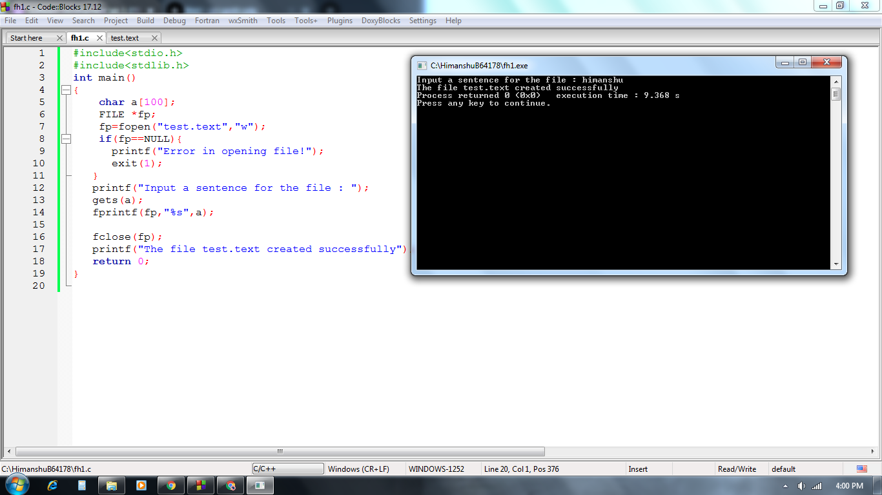

***2.*** *Write a program in C to read an existing file.*

*Test Data :  
Input the file name to be opened : test.txt  
Expected Output :*

*The content of the file test.txt is  :*

*This is the content of the file test.txt.*

**Solution:**

#include<stdio.h>

#include<stdlib.h>

int main()

{

char a;

FILE *fp;

fp=fopen("test.text","r");

if(fp==NULL){

printf(" Error in opening file!");

exit(1);

}

printf("The content of the file test.text is :");

a=fgetc(fp);

while(a != EOF){ //(!feof(fp))

printf("%c",a);

a=fgetc(fp);

}

fclose(fp);

printf("\nThis is the content of the file test.txt");

return 0;

}

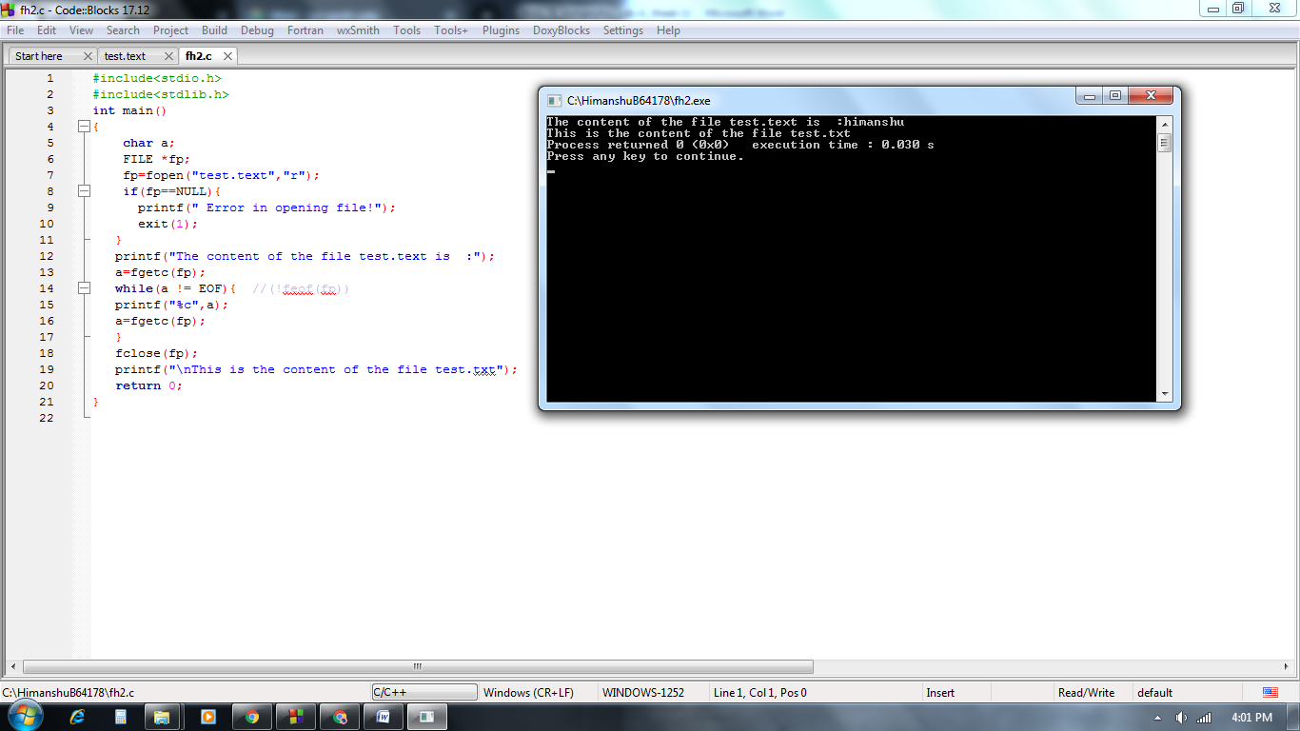

***3.****Write a program in C to write multiple lines in a text file.  
Test Data :  
Input the number of lines to be written : 4  
:: The lines are ::  
test line 1  
test line 2  
test line 3  
test line 4  
Expected Output :*

*The content of the file test.txt is  :*

*test line 1*

*test line 2*

*test line 3*

*test line 4*

**Solution:**

#include <stdio.h>

#include<stdlib.h>

int main ()

{

char a[100],b;

FILE *fp;

fp=fopen("test.text","w");

char fname[20]="test.txt";

int n;

printf("Input the number of lines to be written : ");

scanf("%d", &n);

printf("The lines are :\n");

for(int i = 0; i < n+1; i++)

{

fgets(a, sizeof(a), stdin);

fputs(a, fp);

}

fclose (fp);

fp=fopen("test.text","r");

printf("\nThe content of the file %s is :",fname);

b = fgetc(fp);

while (b != EOF)

{

printf ("%c", b);

b = fgetc(fp);

}

fclose (fp);

return 0;

}

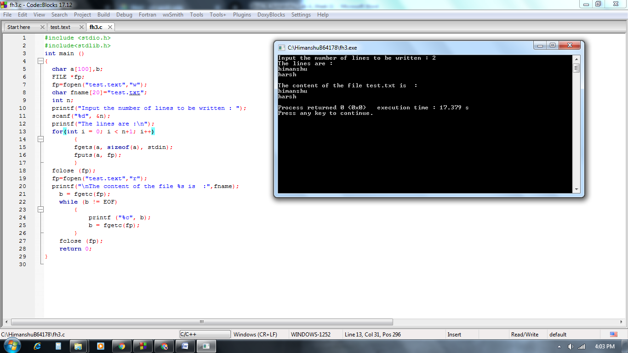

***4.*** *Write a program in C to  find the number of lines in a text file.*

*Enter file name: abc.txt*

*There are 43 lines in the file*

**Solution:**

#include <stdio.h>

int main()

{

FILE *fp;

int c = 0;

char filename[20], chr;

printf("Enter file name: ");

scanf("%s", filename);

fp = fopen(filename, "r");

chr = getc(fp);

while (chr != EOF)

{

if (chr == '\n')

{

c++;

}

chr = getc(fp);

}

fclose(fp);

printf("There are %d lines in %s in a file\n", c, filename);

return 0;

}

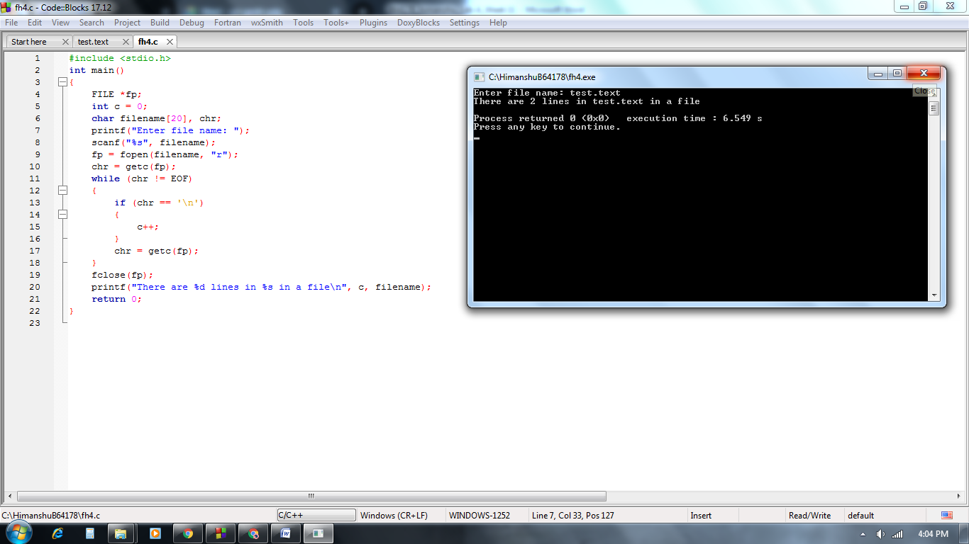

***5.*** *Write a C Program to append the content of file at the end of another.*

*Enter name of first file a.txt*

*Enter name of second file b.txt*

*Enter name to store merged file merge.txt*

*Two files merged merge.txt successfully.*

**Solution:**

#include <stdio.h>

#include <stdlib.h>

int main()

{

FILE *fp1, *fp2, *ft;

char ch, file1[20], file2[20], file3[20];

printf("Enter name of first file ");

gets(file1);

printf("Enter name of second file ");

gets(file2);

printf("Enter name to store merged file ");

gets(file3);

fp1 = fopen(file1, "r");

fp2 = fopen(file2, "r");

if (fp1 == NULL || fp2 == NULL)

{

printf("Error in opening file!");

exit(1);

}

ft = fopen(file3, "w");

if (ft == NULL)

{

printf("Error in opening file!");

exit(1);

}

while ((ch = fgetc(fp1)) != EOF){

fputc(ch, ft);

}

while ((ch = fgetc(fp2) ) != EOF){

fputc(ch, ft);

}

printf("Two files merged %s successfully.", file3);

fclose(fp1);

fclose(fp2);

fclose(ft);

return 0;

}

